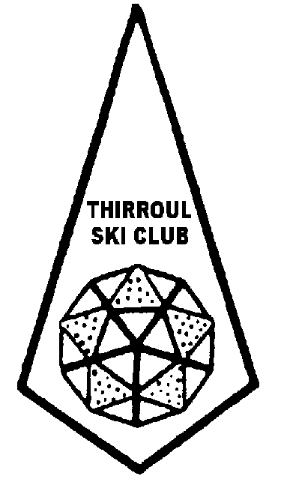
THE THIRROUL SKI CLUB LTD
MARANATHA JUNIOR PROGRAMMES NOMINATION

NAME: |  |  |  | Date of Application:
ADDRESS: |  |  |  | PHONE (Home):
 |  |  |  | (Business):
EMAIL: |  |  |  | (Mobile):
 |  |  |  | Junior Training | Y/N
 |  |  |  | Junior Development | Y/N
This nomination is for the following children |  |  |  | Junior Races | Y/N

Surname | Given Name | Middle Initial | Sex | Child’s Age | D.O.B | Status | For junior races select disciplines  Ski S/Board  XC
 |  |  |  |  |  |  | Ski S/Board XC
 |  |  |  |  |  |  | Ski S/Board XC
 |  |  |  |  |  |  | Ski S/Board XC
 |  |  |  |  |  |  | Ski S/Board XC
 |  |  |  |  |  |  | Ski S/Board XC
*STATUS - Junior Member = JM Child of Member = CM Associate Child = AC

Two race course officials from Thirroul Ski Club are required to be registered with Perisher Race Department for the Brian Donegan Illawarra Interclub junior downhill races. If you are available to be Race Officials please enter your names below:
NAMES:……………………………………………………………………………………………………………….......................................................................................................................................................................

Officials and parents with Working with Children Certificates please enter your names and Working with Children Certificate numbers below:
………………………………………………………………………………………………………………………………………………………………………………………………………………………………………………………………………………………………………………………………………………………………………………
The Thirroul Ski Club Sports Captain will forward the registration link to your email address when the Perisher Race Department make the link available.
Please forward this completed nomination form to:
Email: bookings@thirroulskiclub.com.au and sportscaptain@thirroulskiclub.com.au

OR

Postal: The Booking Officer Signature _________________________
98 Bellevue Road, Figtree, NSW, 2525

